CREATE JAVA APPLICATION

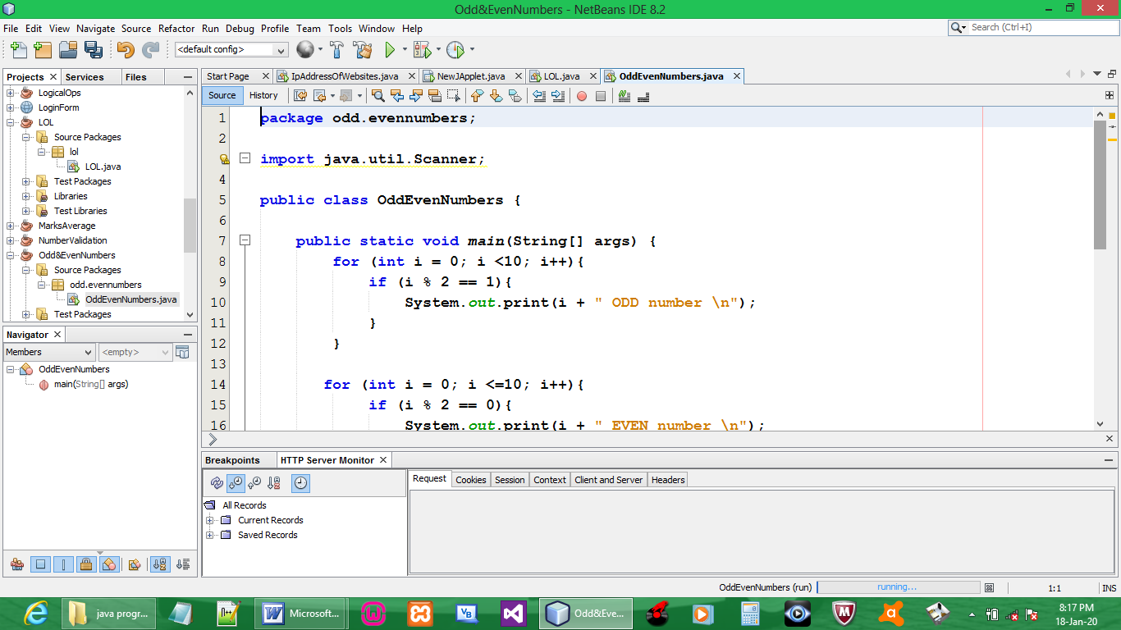

CODE:

package odd.evennumbers;

import java.util.Scanner;

public class OddEvenNumbers {

public static void main(String[] args) {
for (int i = 0; i <10; i++){
if (i % 2 == 1){
System.out.print(i + " ODD number \n");
}
}

for (int i = 0; i <=10; i++){
if (i % 2 == 0){
System.out.print(i + " EVEN number \n");
}
}

}
}

OUTPUT:

